|  |
| --- |
| Flix2U Proposal |

|  |
| --- |
| 16Candles  Professor Gary Heberling  IST 210 Section 005V  Submitted 12/7/18 |

|  |  |
| --- | --- |
| Jun Ki Ahn, Erin Arndt, Bailee Kelley, Madison Shaffer,  Taylan Unal, Zach Ripka | 16Candles |



|  |
| --- |
| II. Table of Contents |

Executive Summary ································································································(2)

Project Overview ································································································ (3-4)

Project Management ·························································································· (5-7)

Project Plan ·································································································· (5)

Resource and Budget ················································································· (6-7)

User Analysis ······································································································ (8-9)

Platform Users ······························································································ (8)

Database Views ···························································································· (9)

Organization of Data ······················································································· (10-13)

Existing Database Analysis and Relationship ·········································· (10-11)

SQL Queries to Create Tables ································································· (12-13)

Database Administration ················································································· (14-15)

Backup and Recovery ················································································· (14)

Data Access and Security ············································································ (15)

Dataloads ··································································································· (15)

Database Dashboard and Analytics ································································· (16-17)

Legal Issues ····································································································· (18-19)

Privacy Statement ······················································································ (18)

Terms of Services ························································································ (19)

Sources Cited ······································································································ (20)

|  |
| --- |
| III. Executive Summary |

Project Overview

|  |
| --- |
| IV. Project Overview |

Flix2You is a well-established movie rental company of 12 years. Flix2You focuses on allowing their customers to make movie rentals online and have them shipped directly to their homes. Flix2You has recently realized that their growth as a company is on the verge of plateauing. To ensure they can stay up to par to compete with their competitors, Netflix, Blockbuster, and Redbox, they must understand their data better to make more knowledgeable business decisions.

Flix2You has been failing to identify their audience, which results in Flix2You not being able to appropriately advertise. In order to better analyze their customers, they need to have better access to their data. This data would potentially hold about 20 million users, which Flix2You would have to quickly adjust to. Currently, Flix2You has over 20,000 unique hits to their website daily that they are unable to identify, which creates a barrier between the potential customer and the company. Having the ability to see who visits their website would allow Flix2You to know which movies they should display on the homepage and which ones to keep in the search bar. The new system will also require that Flix2You managers have both hardcopy reports and an online site for reports that they can see whenever and wherever they would like.

The overall Flix2You problem has a lot of issues to address. These issues include designing new data repository, organizing and creating a database design, creating a backup and recovery plan, analyzing current data in addition to creating data reports, and most importantly analyzing the potential legal issues that could arise from these proposals and changes.

Our Group will begin with a project plan. This plan will begin with a Gantt chart which will be an extension on what is expected of each team member in order to successfully complete the project in a timely manner. The Gantt chart begins on 9/7/2018 and spans to 12/3/2018 with each day having an assigned person with a certain role. With this Gantt chart we can further understand the true scope of the project.

There are 4 main elements of this project: user analysis, organization of data, database administration, and legal issues. For the user analysis section, our group is tasked with identifying old and new user's and their specific access to the new database. These users can have limited controls such as viewing data or have maximum abilities like adding, updating, and managing all of the data. Our group is responsible for deciding who gets limited access to data and who has the authority to receive full access. The organization of data section will focus on analyzing the current database and organizing the data in a way that is more effective and easier to read. We will be using the same database; however, we will be re-designing the entire database in order to reflect Flix2You's new needs. In this new design we will be adding new tables with re-worked entities, relationships, and cardinalities. The new database will have a corresponding ERD, so the user can easily see the relationships that are occurring in the new database.

|  |
| --- |
|  |

The Database Administration section will be an in-depth analysis and identification of the roles and responsibilities that we will be assigning the users of the new database. The expectations of the database administrator will be stated in this section, along with knowledge that we would hope the administrator has. This knowledge includes, but is not limited to, software and hardware,

|  |
| --- |
| IV. Project Overview |

infrastructure, and clustering. We include these skills for a database administrator because it is important that the administrator knows the database inside and out. We hope that these predetermined skills allow the administrator to thrive and succeed in this position.

The Database Administration section will also include a detailed plan of how we suggest Flix2You should backup their data and how to recover said data if necessary. As a team we have agreed to not use a 3rd party data backup and recovery due to its unstable reliability and potential high cost. We believe that it is best to keep backup and recovery within the Flix2You company since this is a new database within the company. Flix2You is a small company and should keep all affairs internal for now.

Since we are confining security to inside the company walls, it is important that those with access are limited to reduce the risk of untrustworthy employees. High company employees and a select few of database administrators will have username/password access to the data. Along with this, a privacy statement will have to be created in order to inform customers of what data Flix2You will have access to and how they are using that data. Since Flix2You will have extensive access to customer data, they are responsible for advertising disclaimers on their website in the form of a fine print at the bottom of each webpage.

All of the above information will be further expanded on in each respective section. After the completion of this project, Flix2You will have a functioning database to further understand their customers, planning for the future of the business. We ensure that the plans we have designed for Flix2You are in the company's best interest and we hope that Flix2You takes our suggestions into consideration.

|  |
| --- |
| V. Project Management |

Flix2You Project Timeline

The Flix2U project will take the entirety of three months. The group will start the project on September 7 and have the final project completed by December 7. This leaves 66 days (excluding weekends) to complete the project and it is expected that the team will work on the project for eight hours per day. Flix2U will take a total of 528 hours to complete.

Weeks 1-4: Understanding and Assessing Flix2You’s Needs

Between weeks one through four, the group members will create a group contract and memorandum of understanding. The contract and memorandum will help in keeping team member on the same page and make sure everyone is staying up-to-date with the project. The project overview will be completed during week two and will detail Flix2You’s current problems and the group’s solutions to the problems. Project management will be completed between week two and week four and details the scheduling throughout the Flix2You project. The Gantt chart will be created in order for team members to assess their performance and completion of their portion of the project. Team roles and responsibilities and budgeting for personnel and necessary resources will also be included in the project management section. The user analysis will be created between during week four and identifies what type of access different employees have to the database, whether it be read access only or both read and write access.

Weeks 5-10: Constructing and Implementing the Database

The Group Initial Report, Organization of Data, Progress Report and Database Administration take place in week five through week 10. The group broke down organization of data into three parts: identify the relationships within the current database, decide between taking a normalized or denormalized approach, and create the tables in the new database. Database administration was also divided into three sections: database backup and recovery, data access and security and dataload.

Weeks 11-12: Create Dashboard Analytics

During weeks eleven and twelve, the group worked on the Database Dashboard and Analytics. Executive at Flix2You want to see what varieties of customers are viewing their website so they can use the data found to make the company more marketable. Researching other established dashboards (week eleven) and then creating the company’s own dashboard (week twelve) were the two main goals of this portion of the project.

Weeks 13-14: Legal Issues, Cover Page, Reflection Report

The group spent week thirteen of the project making the cover page, table of contents and assessing potential legal issues that could arise over the duration of the Flix2You project. The reflection report will be completed during week fourteen as the deadline of the project nears.

|  |
| --- |
| V. Project Management |

Project Resources and Budget:

Roles of Team Members:

The project manager is responsible for creating the action plan and monitoring the other team members to ensure everyone is on the same page throughout the Flix2You project. Once the plan is created, the project manager along with other members on the team will assess the problem and develop the team’s goals. Once team roles are finalized, the project manager creates a schedule to assist in making sure the group members are staying on task and keeping up with the pace of this project. He or she will set the agenda and check in with the group members to confirm progress is being made and lead group discussions as the members move forward throughout the length of the project.

The database architect is held accountable for the creation and implementation of the database. His responsibilities include designing a working and functional database and continuing to monitor its effectiveness throughout the project. He is responsible for correcting any coding errors found within the program. The database architect should make sure the database is user-friendly and easy to access.

The data analyst’s main objective is to collect a variety of vast and useful information about Flix2You’s customer’s preferences. He will then analyze and sort the data to figure out what Flix2You should modify in order to receive a larger customer base. This information, such as a customer’s genre predilections, will be collected and used to improve Flix2You as a company. The data analyst will assist the database architect by sharing his discoveries made through the collection of data found through the customers. It is also the responsibility of the data analyst to ensure the quality of the data being received and how best to use that data to help Flix2You achieve its company goals.

The role of the quality assurance analyst mandates that she performs routine check-ups on the project. She is responsible for reviewing the accuracy of the data and making sure the database is working properly throughout this project. At the end of the project, she is to observe the final product and make sure all questions are answered and all necessary items are found within the group’s solution to Flix2You’s current issues.

The researcher’s activities and duties include finding reputable sources of information for the team members to use as they continue to work on solving Flix2You’s current problem. Additional responsibilities include verifying that all group members are confident in their understanding of the overall problem and tasks at hand. He can assist the team members in maintaining awareness of their roles and overall goals for this project.

The responsibility of the communication and productivity manager requires monitoring the group members to ensure everyone is participating in the completion of this project. She is to make sure the group is up-to-date on the Flix2You project’s goals and conclude every me

eting with a rundown of the main points discussed and make sure all team members have a solid understanding of what needs to be done. Any conflicts the group members may encounter throughout the project will be resolved through the communication and productivity manager.

|  |
| --- |
| V. Project Management |

Personnel Budget

|  |  |  |  |  |
| --- | --- | --- | --- | --- |
| Name | Title | Money Earned per Hour of Work | Total Number of Hours Required | Total Payment |
| Bailee Kelly | Project Manager | $45/hour | 528 | $            23,760.00 |
| Taylan Unal | Database Architect | $43/hour | 528 | $            22,704.00 |
| Jun Ki Ahn | Data Analyst | $41.50/hour | 528 | $            21,912.00 |
| Madison Shaffer | Quality Assurance | $40/hour | 528 | $            21,120.00 |
| Zach Ripka | Researcher | $40/hour | 528 | $            21,120.00 |
| Erin Arndt | Communication and Productivity Manager | $40/hour | 528 | $         21,120.00 |

|  |
| --- |
| VI. User Analysis |

Database User Analysis

The users that will have access to Flix2You will be Flix2You Employees, Customers, and the host (GoDaddy.com). Employees are divided into 4 big parts. There will be 12 Executives that will control upper level managements and administrative support, there will be 18 Managers that will work as a mid-level management and 20 hourly worker that will work as a warehousing and logistics. Even though all four types of users have access to the Flix2You database, they all have different accessibility due to their roles.

Executives are hired to manage upper level management and administrative support that gives the full access to read, add, delete, and modify data in the database because Executives are given the access to read because they need to know what needs to be changed. However, executives that are related to designating system administrations are given all access to data because of emergency, such as hacking, system shutdown, and other malicious activities, System Administration Executives will be given the full charge to database to complete emergency administration when the database administrator employees are not available or unable to handle the situation. Also, site host (godaddy.com) will given full access to database because they will be the host of the site and will support database administrators for smoother handling.

Managers are hired as to take control of mid-level management, such as Customer Satisfaction management, employee management, and gathering of analytical information about the site. Some of the managers will be also hired as database administrators. The managers that is not a database administrator will be given access to only read and modify data transaction data only because they need to know which customer rented which movie to handle movie storage and also need customer information to gather analytics about customer preferences, such as movie ratings. Also, they need only access to modify data only in case of refunds, payment error, and stock changes.

The database administrators are hired in mid-level and upper-level management for managing the database. Database administrator will be the full charge of caring all the information that needs to be altered in necessity. The Database administrators will be given full access to the database in order to fix bugs, add new movies, delete movies, and modify data that needs to be changed. This tasks will be done by mid-level database administrators and upper-level database administrators will check over the changes and help out with tasks that could not be completed by mid-level data base administrators.

The 20 of hourly employee workers will be given access to read the database only because they only need to check information in the database to satisfy customer needs for administration and check number of stocks they received in the warehouse for the warehouse workers. If a customer needs refund or other customer needs that cannot be completed in their level, they need to call the manager who is in charge of the store to help them out.

|  |
| --- |
| VI. User Analysis |

Organizational Access Structure

|  |  |  |  |  |  |
| --- | --- | --- | --- | --- | --- |
| Users | User Type | Database Accessibility | | | |
|  |  | Read | Add | Delete | Modify |
| Filx2You Employees |  |  |  |  |  |
|  | Executives | V | X | X | X |
|  | Managers | V | X | X | V |
|  | Administration | V | X | X | X |
|  | Warehouse Workers | V | X | X | X |
|  | Database Administration | V | V | V | V |
| GoDaddy.com | Supporters | V | V | V | V |

* Customers are only given Access to read database through employee’s assistance because of privacy of database and incase of malicious errors from unethical people

|  |
| --- |
| VII. Organization of Data |

One of the issues that Flix2You is having is that when they run queries is that it slows down the online system often disrupting customer transactions. The first step our company will take to improve the quality and functionality of their database will be to replace their current “off-the-shelf” software with a Microsoft SQL Server. Additionally, 16Candles plans to add more computing resources to Flix2You servers to streamline and speed up the execution of future queries. Our company would also like to implement SSD storage in RAID (Redundant Array of Independent Disks) (Jacobi). RAID allows for perfect copying of data across multiple drives, providing for redundancy in case of failure a new drive can be replaced into the array and data will be copied automatically onto the replacement drive (Jacobi). Typically, less available database memory causes database applications to slow down, so 16Candles would like to upgrade the size and speed of the Flix2You server’s memory for use in database applications. The number of rows in a table can make the database run slower as well because for each query the database has to ‘“look” through all the rows in the table that has been queried to execute the query; to solve this we will consolidate rows where possible and or necessary to ensure that the database will run faster. Redundant variables also make databases run slower and can cause such as inconsistency across tables. Simply utilizing reliable relational database software is not sufficient enough to avoid data redundancy. To reduce data redundancy our company plans to fix this by normalizing the tables (Database Systems 200).

The Flix2You company explains that it is currently difficult for them to query and understand the data in the current database. Properly choosing relations between keys and tables can make it easier to query the system. To make tables more easily understood in the database our company will create user readable table names, variables, and clearly defined relationships that will help the administrators develop and maintain the database.

The Flix2You company voiced their needs for a database that is more easily queried, and to have data that is more easily understood. To meet their needs our company plans to upgrade and streamline their current database as well as their tables and entity relationships between tables.  We plan to update several tables to have more consistent data to ensure that the FLIX2You database administration has better access to quarter report summaries, understanding the purchasing preferences of their customers, and to ensure that their customers will no longer have disruptions during their transactions.

To begin the process of normalization we will analyze the entity’s relationships between the entities; the cardinalities of these relationships (ie. 1:M, M:M, 0:M) will be assessed as well. Our final 3rd Normal Form of the Flix2You database is seen below titled as “Flix2You - ERD Revised 2018”. (Explain why the tables are in 3NF and develop and document SQL necessary for at least of the related tables in the new database structure)

Our company will construct a new ER (entity relationship) diagram for the new database design based on the changes we suggest above. Below, the new recommendation for the new ER-Diagram for Flix2You’s database. This is also the final Third Normal Form of the database (3NF).

|  |
| --- |
| VII. Organization of Data |

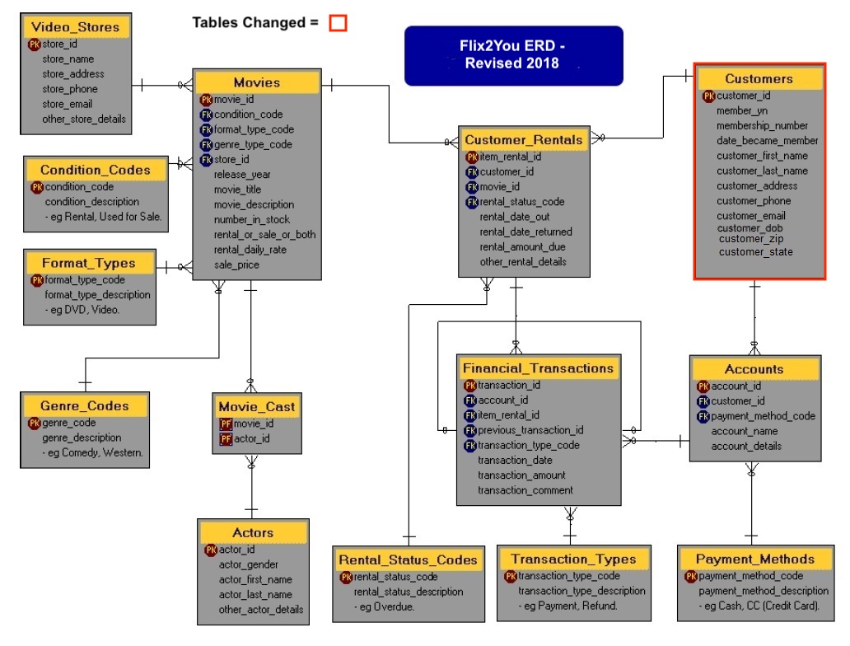

To better understand the purchasing preferences of their customers we plan to update the Customer table. In order to provide more detailed metrics on your customers we plan to isolate the zip code portion of the address value. This means we will be creating two new columns called ‘customer_zip’ and ‘customer_state’. The new Customer table will have a one to zero or many relationships with both Accounts table and the Customer Rentals table. By having the customers zip code and state of residency separated from their address Flix2You will be able to create regional analysis metrics that can determine regional purchasing habits of your customers. This also helps reduce data entry errors by the customers themselves by only being able to enter a state’s initials and only being able to enter a nine-digit postal zip code. By understanding where your customers are, you can also see where your customers are not, and establish ad campaigns to further the FLIX2You company’s customer base.

Our company will implement these new changes to the Flix2You database by inserting the new tables and their columns using SQL. Below is a sample of the SQL code that we used to insert the new table, Customer, as well as the Accounts table and the Financial Transactions table. First, we had to drop the table, then create it again with the new table columns that will streamline and improve understanding of customer data.

|  |
| --- |
| VII. Organization of Data |

SQL Code for Updating Table “Customer”:

DROP TABLE customers

CREATE TABLE customers(

customer_id int IDENTITY(1,1) NOT NULL,

member_yn varchar(50) NOT NULL,

membership_number varchar(16) NOT NULL,

date_became_member datetime NOT NULL,

customer_first_name varchar(32) NOT NULL,

customer_last_name varchar(32) NOT NULL,

customer_address varchar(128) NOT NULL,

customer_zip varchar (9) NOT NULL,

customer_state varchar(2) NOT NULL,

customer_phone varchar(12) NOT NULL,

customer_email varchar(128) NOT NULL,

customer_dob datetime NOT NULL);

ALTER TABLE customers ADD CONSTRAINT pk_customer PRIMARY KEY (Customer_Id);

Populating “Customer” Table with sample data:

INSERT INTO customer values (‘id’, ‘yn’, ‘membership number’, ‘date became member’, ‘cust f name’, ‘cust l name’, ‘address’, ‘zip’, ‘state’, ‘phone’, ‘email’, ‘dob’)

INSERT INTO customer values (‘001’, ‘2012’, ‘30897’, ‘11-23-2012’, ‘David’, ‘Bowie’, ‘123 Life on Mars Ave’, ‘627716046’, ‘PA’, ‘8148675309’, ‘ziggystardust@gmail.com’, ‘8-1-1947’)

SQL Code for Creating Table “Accounts”:

CREATE TABLE accounts(

account_id int IDENTITY(1,1) NOT NULL,

customer_id int NOT NULL,

payment_method_code int NOT NULL,

account_name varchar(64) NOT NULL,

account_details varchar(128) NOT NULL);

ALTER TABLE accounts ADD CONSTRAINT pk_accounts PRIMARY KEY (account_id);

ALTER TABLE accounts ADD CONSTRAINT fk_accounts_payment_methods FOREIGN KEY(payment_method_code)

REFERENCES payment_methods (payment_method_code);

|  |
| --- |
| VII. Organization of Data |

Populating “Accounts” Table with sample data:

INSERT INTO accounts VALUES ('001', '101', 'Debit', ' David Bowie', 'PNC Debit')

INSERT INTO accounts VALUES ('002', '102', 'Credit', ' Freddie Mercury', 'Amex Credit')

INSERT INTO accounts VALUES ('003', '103', 'Check', ' Cyndi Lauper ', 'Bank of America')

SQL Code for Creating Table “Financial_Transactions”:

CREATE TABLE financial_transactions(

transaction_id int IDENTITY (1,1) NOT NULL,

account_id int NOT NULL,

item_rental_id int NOT NULL,

previous_transaction_id int NULL,

transaction_type_code int NOT NULL,

transaction_date date NULL,

transaction_amount money NOT NULL,

transaction_comment varchar(128) NOT NULL);

ALTER TABLE financial_transactions ADD  CONSTRAINT fk_Financial_transactions_account_id FOREIGN KEY(account_id)

REFERENCES accounts (account_id);

ALTER TABLE financial_transactions ADD  CONSTRAINT fk_Financial_transactions_customer_rentals FOREIGN KEY(item_rental_id)

REFERENCES customer_rentals (item_rental_id);

ALTER TABLE financial_transactions ADD  CONSTRAINT fk_financial_transactions_transaction_types FOREIGN KEY(transaction_type_code)

REFERENCES transaction_types (transaction_type_code);

ALTER TABLE financial_transactions ADD  CONSTRAINT fk_financial_transactions_previous_transaction_id FOREIGN KEY(previous_transaction_id)

REFERENCES financial_transactions (transaction_id);

Populating “Transaction_Types” Table with sample data:

INSERT INTO transaction_types values ('Credit');  
INSERT INTO transaction_types values ('Debit');  
INSERT INTO transaction_types values ('Cash');  
INSERT INTO transaction_types values ('Check');

|  |
| --- |
| VIII. Database Administration |

Roles and Responsibilities of Database Administrator (in order for them to succeed).

The role of a database administrator to the success of a database solution is paramount.  Since data is one of Flix2You’s main assets in understanding their customers and their profit goals, Flix2You will need a DBMS (database management system) (*Database Systems* 777). Our company will provide a DBMS for Flix2You that will produce quality, understandable and applicable information that will make financial and marketing decision making much easier and ultimately more profitable in both the short run and the long run for the Flix2You company.

* (can probably find these in the book)
* Hardware knowledge necessary
* Software knowledge necessary
* Infrastructure knowledge necessary
* Clustering knowledge necessary

Database Backup and Recovery

Backups and rescue plans are critical to business continuity. Not using a third party backup source.

* How data should be stored
* How data should be backed up
* How to address and remediate technical issues (that may occur while using the site)
* “Outsourced 3rd solutions can be utilized. Note that any work contracted by 3rd Party solutions should be investigated for security, reliability, and cost.”

Data Access and Security

* Security measures needed to ensure the system cannot be breached
* Database Security
  + How database will be secured to ensure people with correct login/password will be able to access the data
    - Restrict characters ie (%$&*#)
* Privacy statement
  + How will customers data be used? (maybe we should refer to other privacy statements of Netflix to get a feel for what we need to include?)
* Anticipate legal implications/disclaimers that users must see
  + Should employees sign disclaimers?

Dataload

* Will we use a “new read only” that pulls data from an operational database?
* What is our plan? How do we intend on updating the data that will be contained in the proposed database design?
* If creating a new database with new/edited tables (we will)
  + How will we migrate to the new system without causing disturbances?
  + Maybe have updates occur in the middle of the night when there is less site traffic?

|  |
| --- |
| VIII. Database Administration |

|  |
| --- |
| IX. Database Dashboard & Analytics |

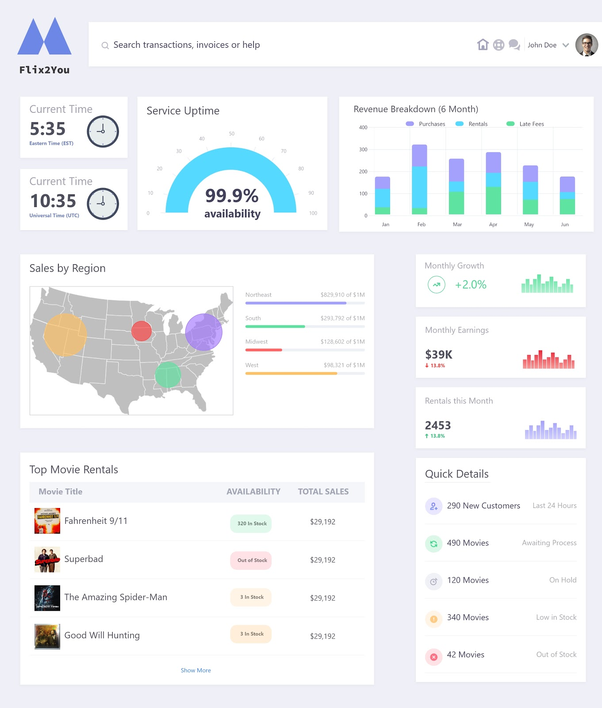

|  |
| --- |
| IX. Database Dashboard & Analytics |

Database Dashboard and Analytics

The executives of Flix2you will require a dashboard that is easily manageable and functional. This means that the dashboard should be easy to understand and creates relevant charts, graphs, statistics, etc. Also, the dashboard should easily be able to export to a MS Excel spreadsheet and print to a .pdf. The dashboard must have a secure log in and a display that shows weekly reports based on the users of Flix2you. The weekly reports will show data such as sales and demographics. The decision had to be made whether or not to outsource the dashboard creation or create it on our own.

However the dashboard is created, it must show the following information: movie name, rating, the day of the rental (what day of the week), how often the movie is rented, revenue (based on the company), monthly quarterly revenues, number of downloads, sales, and number of new members.

There are pros and cons to both implementing our own dashboard or outsourcing to an already created means of entering and showing data. Based on what we require, our team had decided to outsource to either Power BI by Microsoft or Google Dashboard. We decided to go with Power BI by Microsoft because it does everything we need it to do for a good price. We will pay a monthly subscription based on the number of total users within Flix2you. This will be a better method than having to hire additional employees to design, create, facilitate, and implement a totally new dashboard software. Power BI is easy to learn, so current employees can learn the software and how to interact with it. We may need to hire at least an employee or two that can help implement the Power BI software into everyday use and train current employees, but hiring a full staff will not be necessary.

Power BI is a cloud-based business analytics service (“What Is Power BI?”). It will allow us to give a single view of all of the critical areas that the Flix2you executives desire. Power BI will let our company check on the status of business with a live dashboard and it will also allow us to create interactive reports of data. Another great feature is that Power BI has mobile applications, which is required by the executives. This will allow us to easily manipulate the dashboard on mobile phones and tablets. Power BI also has a secure log in as well, but whoever has login access can share with unauthenticated users. For this reason, it is important to assign log in access to specific employees and executives. Who has access to the login has to be kept track of in order to prevent inadvertent sharing of data. Lastly, Power BI gives the ability to add a gateway to sql server if access is not already granted (“What Is Power BI?”). The version of Power BI that we use will have access to SQL server built in.

|  |
| --- |
| X. Legal Issues |

Privacy Policy

16Candles cares deeply about Flix2You’s customer’s personal information security and privacy. 16Candles handles Customer’s Personally Identifiable Information (PII) with the utmost discretion, only accessing or modifying entries that have changed and are confirmed by the customer or have been corrupted/no longer necessary. Personally Identifiable Information includes data that Flix2You does collect, including: Date of Birth, Payment Details, Credit Card Details, Home Address, Email Address, and Phone Number.

This information, along with more common details like first and last names, as well as purchase/rental history, will be used to improve the customer experience as Flix2You learns your purchasing patterns, payment methods, and we learn which rental titles we should offer in-stores and online. We strive to keep as little information as we can on customers, limiting our risk to potential internal/external attacks. Any information that we do keep is held as long as a customer requests that we keep it on the database. Account removal processes are built into the server and can be requested online or in-store. After a removal request is put in, we ask that customers allow for up to 5-7 business days for the removal to be fully processed. Users can also request their personal information in order to update it in store by speaking to a manager on-site at our Flix2You locations across the country.

Customers can access the company’s public website, as well as their personal information by logging into their account online. In order to preserve customer’s data security, no personal details will be shown online, without additional verification such as password reentry/two-factor authentication.

These details will be kept behind Windows Authentication using Kerberos Encryption featured in Microsoft SQL Server, with authorized users being managed within an Active Directory structure. Database Administrators will separate employees (users) into groups, each with different levels of permissions and access authorization to the database. Flix2You utilizes a private cloud to manage company data, as well its customer’s data, all kept behind host firewalls as well as network-based firewalls. 16Candles reaffirms its commitment to limiting customer data collection and the security of the data that it does collect on customers through the security and data collection processes outlined in this Privacy Statement. 16Candles or Flix2You reserves the right to change this Privacy Policy at any time, posting the changes on its blog, updates sent through email, and posted in each of our locations.

|  |
| --- |
| X. Legal Issues |

Terms and Conditions:

Flix2You operates in all 50 States, with convenient locations for our customers with more opening every year. Orders can be placed both online and in store, and shipping options are available for customer’s convenience. Flix2You uses an integrated ticketing system in which purchases online and in-stores will be kept in sync, and previous orders can be tracked online. This purchase history is used by Flix2You to provide customer’s history to them and generate relevant recommendations for future movie rentals.

Flix2You accepts many forms of payments for its rentals and purchases, including credit, cash, check, and offers mobile payments (Apple Pay/Google Pay) both in store and on its mobile site online. Any payments made will be retained by Flix2You after the refund period expires, barring extenuating circumstances that will be handled by the Flix2You support team or by in-store management.

Flix2You offers a generous refund policy, allowing for 4-hour refunds on our daily and weekly rentals. We offer these refunds as a way for customers to find the movie for the right time from us, no questions asked. After those periods, however, we consider our rentals to be confirmed, and will charge the full price of the rental to the credit/check payment and retain any cash payment made for the rental.

Flix2You must assess late fees for its rentals, and we will have to charge 100% of the rental fee per day that the rental hasn't been returned, up to the sticker price of the movie. These late fees are non-refundable and will be assessed to the customer’s original payment method or will be deducted from their account balance.

Any pirating, ‘ripping’, or any act of retaining a copy of a product rented from Flix2You is strictly prohibited. Any instances of copying or pirating of Flix2You media will be referred to the appropriate authorities under the DMCA as well as an immediate ban from using the Flix2You service in the future. Replacing an original Flix2You product with a copy or falsified disc into the box is strictly prohibited and will result in an immediate ban from using the Flix2You service in the future.

Violations of the Terms and Conditions as stated above may result in penalties such as additional penalties or legal action taken against the customer by Flix2You or appropriate authorities. These Terms and Conditions are subject to change at any time by Flix2You; any changes will be emailed, updated on our website, and posted in our in store locations.

|  |
| --- |
| XI. Sources Cited |

“What Is Power BI?” *What Is Power BI | Microsoft Power BI*, powerbi.microsoft.com/en-us/what-is-power-bi/.

(2019). *Database Systems: Design, Implementation, & Management, 13th Edition*. [Yuzu]. Retrieved from https://reader.yuzu.com/#/books/undefined/

(2012). Jacobi, Jon, L. *RAID Made Easy.* Retrieved from: https://www.pcworld.com/article/194360/raid-made-easy.html